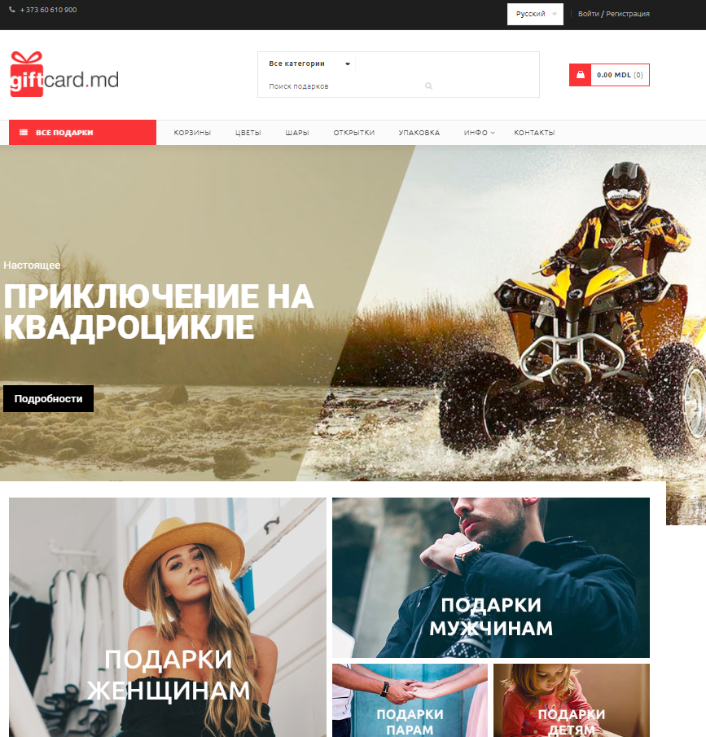

Disponibil: <https://giftcard.md/>

|  |  |  |  |  |  |  |  |  |  |
| --- | --- | --- | --- | --- | --- | --- | --- | --- | --- |
| **Heading** | | **Text de baza** | | **Menu** | | **Butoane** | | **Footer** | |
| *Font* | Ubuntu | *Font* | Ubuntu | *Font* | Ubuntu | *Font* | Ubuntu | *Font* | Ubuntu |
| *Dimensiune* | 14px | *Dimensiune* | 14px/16px | *Dimensiune* | 14px | *Dimensiune* | 12px | *Dimensiune* | 14px |
| *Aliniere* | centru-vertical | *Aliniere* | center | *Aliniere* | left | *Aliniere* | center | *Aliniere* | center |
| *Culoare* | gri-cafiniu(#3f3f3f) | *Culoare* | gri-cafiniu (#3f3f3f) | *Culoare* | gri-negru(#1c1c1c;) | *Culoare* | gri-posomorit (#666666) | *Culoare(font)* | gri-deschis(#999999) |
|  |  |  |  |  |  |  |  | *bakground* | negru |

Disponibil: <https://www.zdg.md/reporter-special/reportaje/mame-pentru-mame-daca-nu-noi-atunci-cine-le-va-ajuta/>

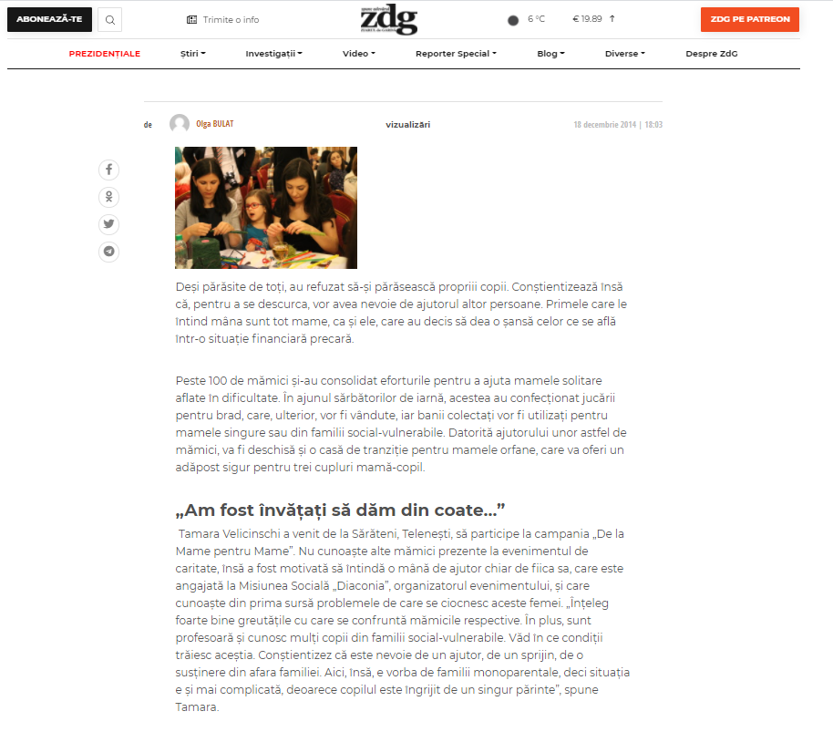

|  |  |  |  |  |  |  |  |  |  |
| --- | --- | --- | --- | --- | --- | --- | --- | --- | --- |
| **Heading** | | **Text de baza** | | **Menu** | | **Butoane** | | **Footer** | |
| *Font* | Montserrat', sans-serif | *Font* | 'Montserrat', sans-serif | *Font* | Montserrat', sans-serif | *Font* | Montserrat', sans-serif | *Font* | Montserrat', sans-serif |
| *Dimensiune* | 14px | *Dimensiune* | 18px | *Dimensiune* | 14px | *Dimensiune* | 14px | *Dimensiune* | 14px |
| *Aliniere* | vertical-center | *Aliniere* | right | *Aliniere* | right | *Aliniere* | center | *Aliniere* | justify |
| *Culoare* | negru(#161616) | *Culoare* | мокрый асфальт(#4f4f4f) | *Culoare* | negru(#161616) | *Culoare* | alb(#FFF) | *Culoare(font)* | Перламутровый темно-серый(#828282) |
| *Bakground* | transparent |  |  |  |  | *Background* | rosu(#f24d21)/negru(#171717) | *Bakground* | transparent |

Disponibil: <http://bvprint.ru/lam/>

|  |  |  |  |  |  |  |  |  |  |
| --- | --- | --- | --- | --- | --- | --- | --- | --- | --- |
| **Heading** | | **Text de baza** | | **Menu** | | **butoane** | | **footer** | |
| *Font* | Tahoma,sans-serif | *Font* | Tahoma,sans-serif | *Font* | Tahoma,sans-serif | *Font* | Tahoma,sans-serif | *Font* | Tahoma,sans-serif |
| *Dimensiune* | 14 px | *Dimensiune* | 14 px | *Dimensiune* | 12 px | *Dimensiune* | 8 px | *Dimensiune* | 10 px |
| *Aliniere* |  | *Aliniere* | Right | *Aliniere* | Left | *Aliniere* | Center | *Aliniere* | Left |
| *Culoare* | Тусклый серый(#666) | *Culoare* | Negru | *Culoare* | Светлый сине-серый(#648ea9) | *Culoare* | Тусклый серый(#666) | *Culoare(font)* | Перламутровый темно-серый(#828282) |
| *Bakground* | Гридеперлевый(#e9eceb) |  |  |  |  | *Background* | Гридеперлевый(#e9eceb) | *Bakground* | Гридеперлевый(#e9eceb) |

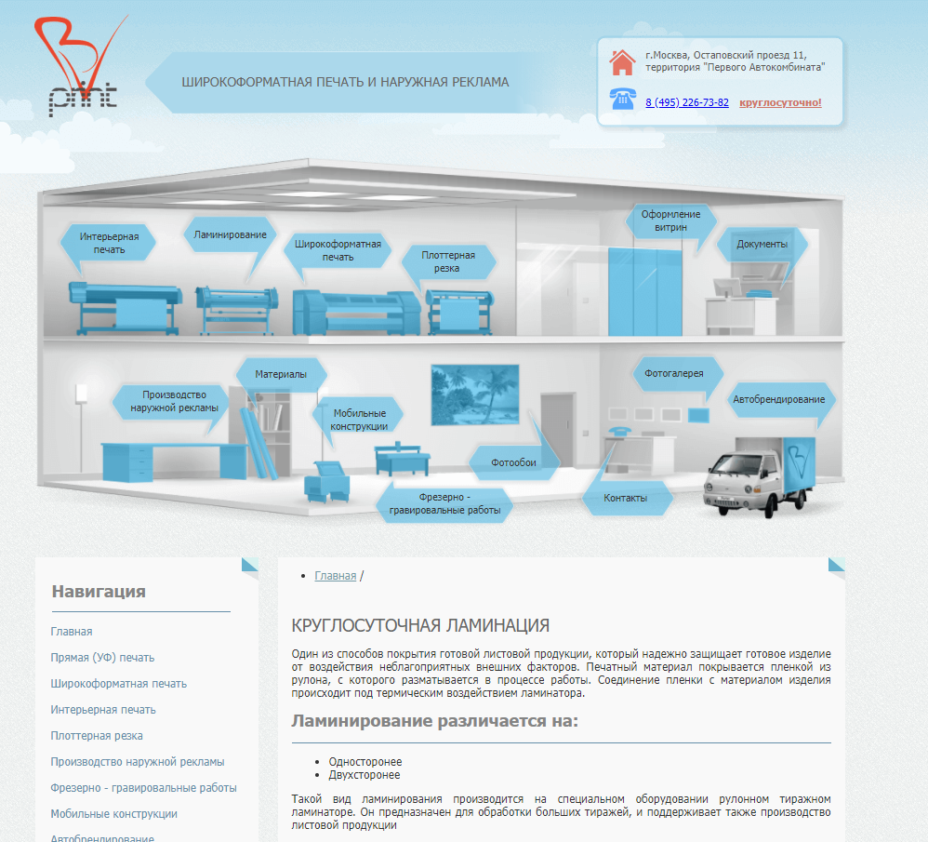

Disponibil: <https://sportschools.ru/page.php?name=billiard_item>

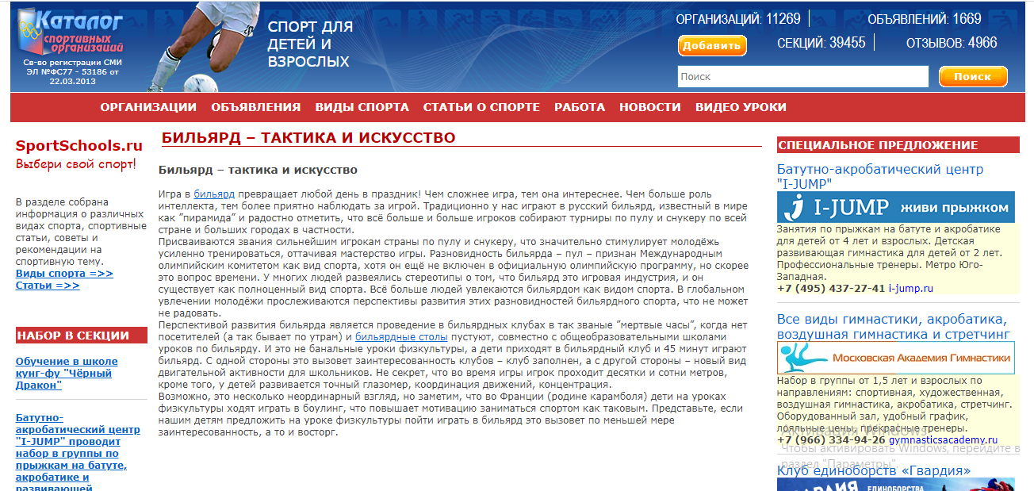

|  |  |  |  |  |  |  |  |  |  |
| --- | --- | --- | --- | --- | --- | --- | --- | --- | --- |
| **Heading** | | **Text de baza** | | **Menu** | | **Butoane** | | **Footer** | |
| *Font* | Verdana,tahoma,arial | *Font* | Verdana,tahoma,arial | *Font* | Verdana,tahoma,arial | *Font* | Verdana | *Font* | Verdana |
| *Dimensiune* | 14px | *Dimensiune* | 14px | *Dimensiune* | 14px | *Dimensiune* | 12px | *Dimensiune* | 14px |
| *Aliniere* | Vertical-center | *Aliniere* | Right | *Aliniere* | Right | *Aliniere* | Center | *Aliniere* |  |
| *Culoare* | Alb | *Culoare* | Gri-cafiniu(#3f3f3f) | *Culoare* | Alb | *Culoare* | Alb | *Culoare(font)* | Перламутровый светло-серый(#999999) |
| *Bakground* |  |  |  |  |  | *Background* | Насыщенный оранжево-желтый(#fb9213) | *Bakground* | Transparent |

Disponibil: <https://bigshop.md/ro/mobila-c35>

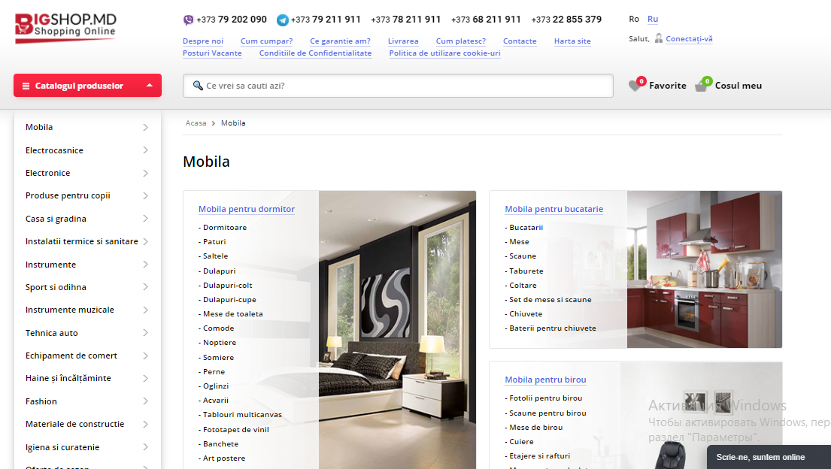

|  |  |  |  |  |  |  |  |  |  |
| --- | --- | --- | --- | --- | --- | --- | --- | --- | --- |
| **Heading** | | **Text de baza** | | **Menu** | | **butoane** | | **footer** | |
| *Font* | Open sans,sans-serif | *Font* | Open sans,sans-serif | *Font* | Open sans,sans-serif | *Font* | Open sans,sans-serif | *Font* | Open sans,sans-serif |
| *Dimensiune* | 13px | *Dimensiune* | 13px | *Dimensiune* | 13px | *Dimensiune* | 13px | *Dimensiune* | 14px |
| *Aliniere* | Left | *Aliniere* | Left | *Aliniere* | Left | *Aliniere* | Center | *Aliniere* | Center |
| *Culoare* | Королевско-синий(#445be0) | *Culoare* | Negru | *Culoare* | Королевско-синий(#445be0) | *Culoare* | Negru | *Culoare(font)* | Очень бледный синий(#d3d5da) |
| *Bakground* | Transparent |  |  |  |  | *Background* | Transpatent | *Bakground* | Negru |

Disponibil: <https://lapkins.ru/cat/orientalnaya-koshka/>

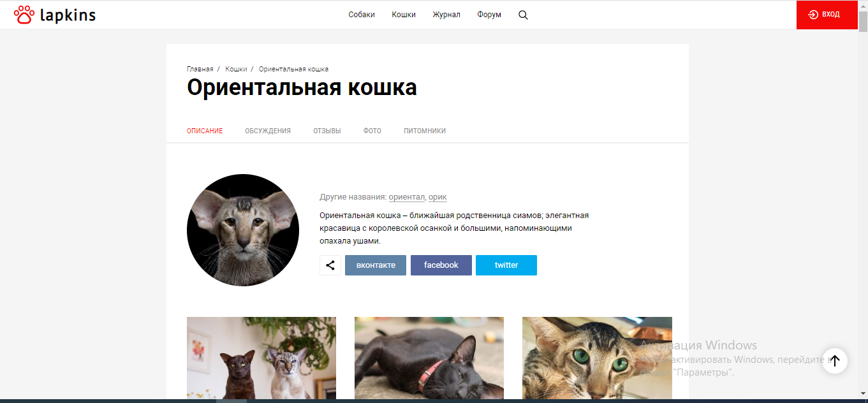

|  |  |  |  |  |  |  |  |  |  |
| --- | --- | --- | --- | --- | --- | --- | --- | --- | --- |
| **Heading** | | **Text de baza** | | **Menu** | | **butoane** | | **footer** | |
| *Font* | Roboto, arial | *Font* | Roboto, arial | *Font* | Roboto, arial | *Font* | Roboto, arial | *Font* | Roboto, arial |
| *Dimensiune* | 15px | *Dimensiune* | 17px | *Dimensiune* | 15px | *Dimensiune* | 13px | *Dimensiune* | 13px |
| *Aliniere* | Vertical-center | *Aliniere* | Left | *Aliniere* | Left | *Aliniere* | Center | *Aliniere* | Left |
| *Culoare* | Negru | *Culoare* | Negru | *Culoare* | Перламутровый темно-серый(#828282) | *Culoare* | Alb | *Culoare(font)* | Negru |
| *Bakground* | Transparent |  |  |  |  | *Background* | Люминесцентный красный(#f40909) | *Bakground* | Transparent |

Disponibil: <https://papermax.md/ro/193-sarbatori>

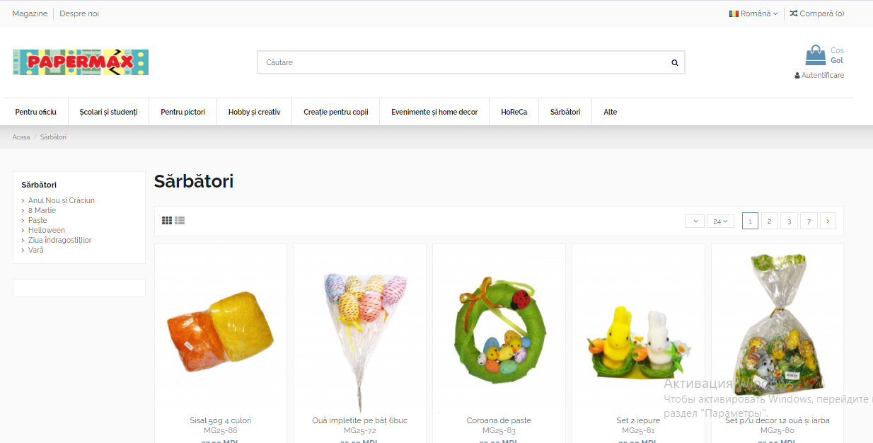

|  |  |  |  |  |  |  |  |  |  |
| --- | --- | --- | --- | --- | --- | --- | --- | --- | --- |
| **Heading** | | **Text de baza** | | **Menu** | | **butoane** | | **footer** | |
| *Font* | 'Raleway',sans-serif; | *Font* | 'Raleway',sans-serif; | *Font* | 'Raleway',sans-serif; | *Font* | 'Raleway',sans-serif; | *Font* | 'Raleway',sans-serif; |
| *Dimensiune* | 14px | *Dimensiune* | 14px | *Dimensiune* | 12px | *Dimensiune* | 13px | *Dimensiune* | 13px |
| *Aliniere* | Left | *Aliniere* | Left | *Aliniere* | Left | *Aliniere* | Center | *Aliniere* | Left |
| *Culoare* | Цвет мокрого асфальта(#484848) | *Culoare* | Графитно-черный(#1d1d1d) | *Culoare* | Графитно-черный(#1d1d1d) | *Culoare* | Цвет мокрого асфальта(#484848) | *Culoare(font)* | Alb |
| *Bakground* | Дымчато-белый(#f0f0f0) |  |  |  |  | *Background* | Transparent | *Bakground* | Negru |

Disponibil: <https://www.pandashop.md/ru/catalog/home_garden/furniture/>

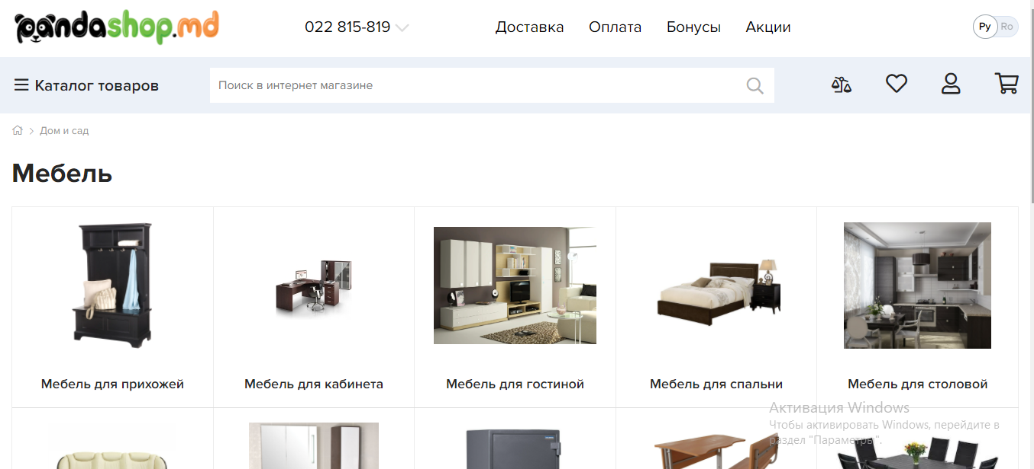

|  |  |  |  |  |  |  |  |  |  |
| --- | --- | --- | --- | --- | --- | --- | --- | --- | --- |
| **Heading** | | **Text de baza** | | **Menu** | | **butoane** | | **footer** | |
| *font* | ProximaNova-Reg | *font* | ProximaNova-Semibold | *font* | ProximaNova-Bold | *font* | ProximaNova-Semibold | *font* | ProximaNova-Reg |
| *dimensiune* | 20px | *dimensiune* | 18px | *dimensiune* | 16px | *dimensiune* | 18px | *dimensiune* | 16px |
| *aliniere* | vertical-center | *aliniere* | center | *aliniere* | left | *aliniere* | center | *aliniere* | left |
| *culoare* | negru | *culoare* | negru | *culoare* | negru | *culoare* | negru | *culoare(font)* | negru |
| *bakground* | transparent |  |  |  |  | *background* | Светло-серый(#B2B2B2) | *bakground* | transparent |

Disponibil: <https://www.paradis.md/ru/katalog/yuvelirnye-izdeliya?sf_params=f979e2607734aaf8467329b8e926d969&mid=167&id=3&sf_orderby=date&sf_order=desc&sf_start=0&category_id=9&manufacturer_id=0>

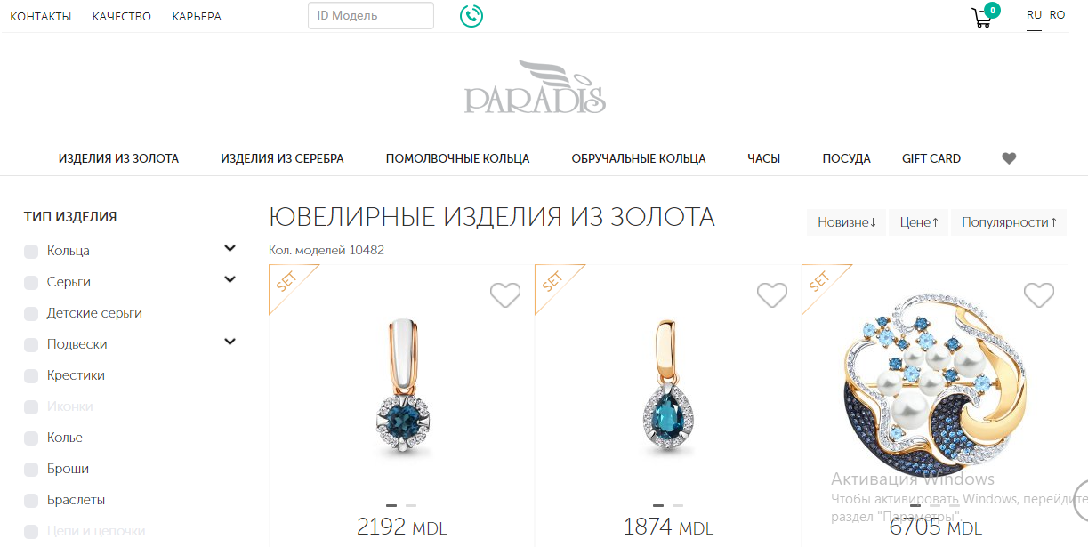

|  |  |  |  |  |  |  |  |  |  |
| --- | --- | --- | --- | --- | --- | --- | --- | --- | --- |
| **Heading** | | **Text de baza** | | **Menu** | | **butoane** | | **footer** | |
| *Font* | Opensans | *Font* | Museo | *Font* | Museobold | *Font* | Museobold | *Font* | Opensans |
| *Dimensiune* | 13px | *Dimensiune* | 16px | *Dimensiune* | 10,5px | *Dimensiune* | 14px | *Dimensiune* | 15px |
| *Aliniere* | Left | *Aliniere* | Left | *Aliniere* | Left | *Aliniere* | Left | *Aliniere* | Left |
| *Culoare* | Negru(#2b2b2b) | *Culoare* | Negru(#2b2b2b) | *Culoare* | Negru | *Culoare* | Negru(#2b2b2b) | *Culoare(font)* | Negru(#2b2b2b) |
| *Bakground* | Transparent |  |  |  |  | *Background* | Alb | *Bakground* | Transparent |

Disponibil: <https://www.biroticexpert.md/termeni-si-conditii-de-livrare/>

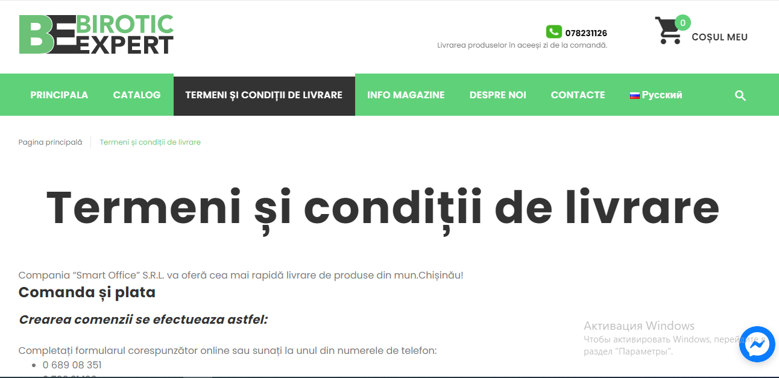

|  |  |  |  |  |  |  |  |  |  |
| --- | --- | --- | --- | --- | --- | --- | --- | --- | --- |
| **Heading** | | **Text de baza** | | **Menu** | | **Butoane** | | **Footer** | |
| *Font* | Poppins", sans-serif; | *Font* | Poppins", sans-serif; | *Font* | Poppins", sans-serif; | *Font* | Poppins", sans-serif; | *Font* | Poppins", sans-serif; |
| *Dimensiune* | 12px | *Dimensiune* | 16px | *Dimensiune* | 16px | *Dimensiune* | 16px | *Dimensiune* | 16px |
| *Aliniere* | Center | *Aliniere* | Left | *Aliniere* | Left | *Aliniere* | Left | *Aliniere* | Left |
| *Culoare* | Sur(#777777) | *Culoare* | Sur(#777777) | *Culoare* | Alb | *Culoare* | Negru | *Culoare(font)* | Sur(#777777) |
| *Bakground* | Transparent |  |  |  |  | *Background* | Transparent | *Bakground* | Negru |

Disponibil: <https://librarius.md/ro/offices/subcategory/75>

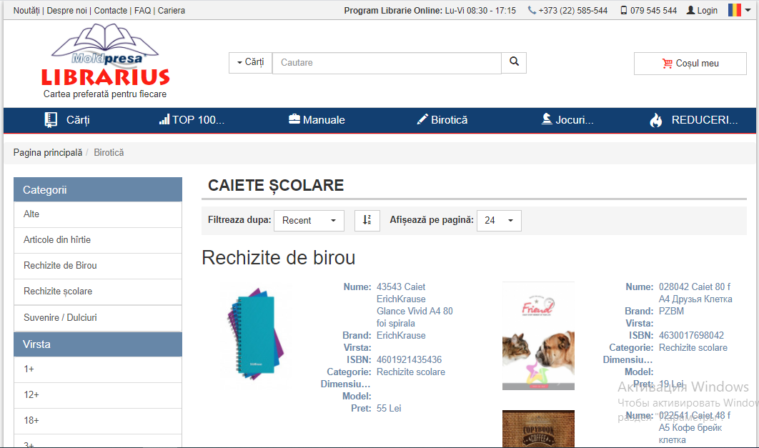

|  |  |  |  |  |  |  |  |  |  |
| --- | --- | --- | --- | --- | --- | --- | --- | --- | --- |
| **Heading** | | **Text de baza** | | **Menu** | | **butoane** | | **footer** | |
| *Font* | Roboto,sans-serif | *Font* | Roboto,sans-serif | *Font* | Roboto,sans-serif | *Font* | Roboto,sans-serif | *Font* | Roboto,sans-serif |
| *Dimensiune* | 14px | *Dimensiune* | 14px | *Dimensiune* | 14px | *Dimensiune* | 14px | *Dimensiune* | 14px |
| *Aliniere* | Left | *Aliniere* | Left | *Aliniere* | Left | *Aliniere* | Left | *Aliniere* | Left |
| *Culoare* | Negru | *Culoare* | Светлый сине-серый(#6787a8) | *Culoare* | Alb | *Culoare* | Negru | *Culoare(font)* | Alb |
| *Bakground* | Transparent |  |  |  |  | *Background* | Transparent | *Bakground* | Sur |

Disponibil: <https://dekoriko.ru/dizajn/dom/interer/>

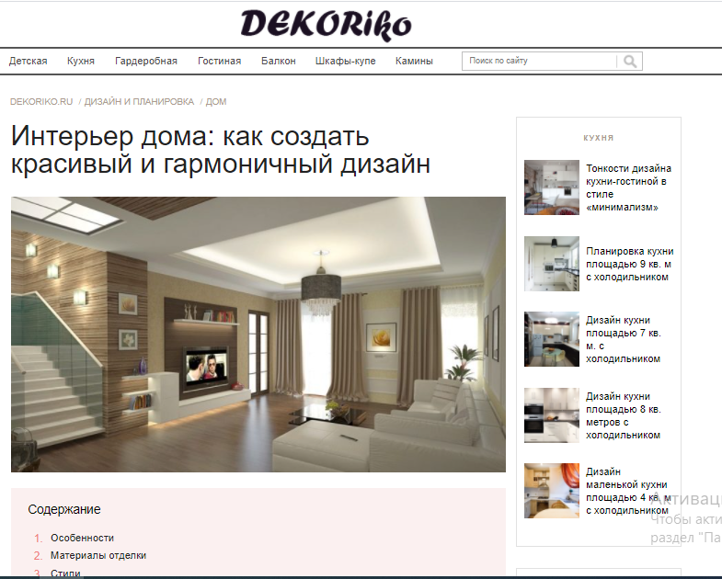

|  |  |  |  |  |  |  |  |  |  |
| --- | --- | --- | --- | --- | --- | --- | --- | --- | --- |
| **Heading** | | **Text de baza** | | **Menu** | | **butoane** | | **footer** | |
| *Font* | Sans-serif | *Font* | Pt sans caption | *Font* | Sans-serif | *Font* | Pt sans caption, sans-serif | *Font* | Pt sans caption, sans-serif |
| *Dimensiune* | 15px | *Dimensiune* | 15px | *Dimensiune* | 15px | *Dimensiune* | 15px | *Dimensiune* | 15px |
| *Aliniere* | Left | *Aliniere* | Left | *Aliniere* | Left | *Aliniere* | Center | *Aliniere* | Left |
| *Culoare* | Мокрый асфальт(#484848) | *Culoare* | Negru | *Culoare* | Мокрый асфальт(#484848) | *Culoare* | Alb | *Culoare(font)* | Перламутровый темно-серый(#828282) |
| *Bakground* | Transparent |  |  |  |  | *Background* | Скарлет(#ff2d54) | *Bakground* | Transparent |

Disponibil: <https://www.pichshop.ru/catalog/gift/>

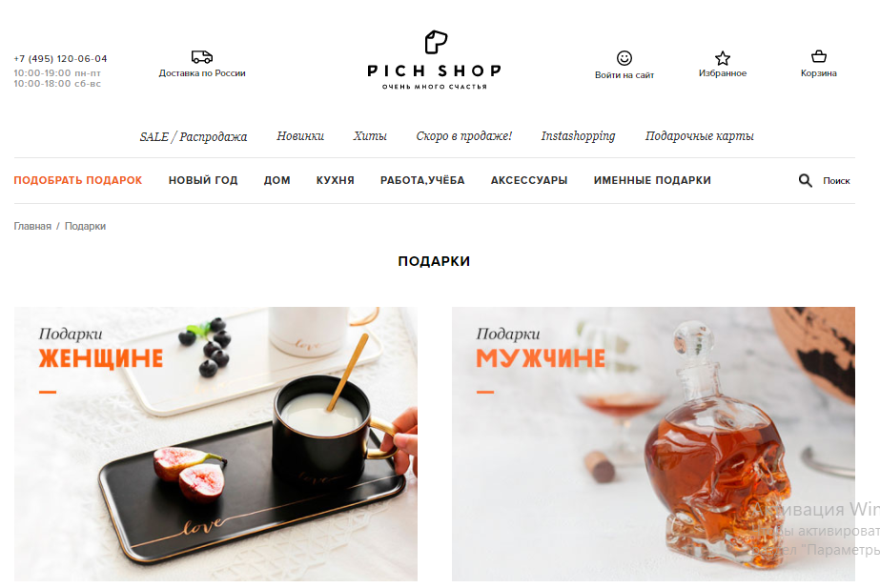

|  |  |  |  |  |  |  |  |  |  |
| --- | --- | --- | --- | --- | --- | --- | --- | --- | --- |
| **Heading** | | **Text de baza** | | **Menu** | | **butoane** | | **footer** | |
| *Font* | Georgia | *Font* | Proxima-nova | *Font* | Proxima-nova | *Font* | Proxima-nova | *Font* | Proxima-nova |
| *Dimensiune* | 13px | *Dimensiune* | 13px | *Dimensiune* | 12px | *Dimensiune* | 11px | *Dimensiune* | 13px |
| *Aliniere* | Left | *Aliniere* | Left | *Aliniere* | Left | *Aliniere* | Left | *Aliniere* | Left |
| *Culoare* | Negru | *Culoare* | Negru | *Culoare* | Negru | *Culoare* | Negru | *Culoare(font)* | Negru |
| *Bakground* | Transparent |  |  |  |  | *Background* | Transparent | *Bakground* | Transparent |

Disponibil: <https://jysk.md/category/perne-51?lang=ro>

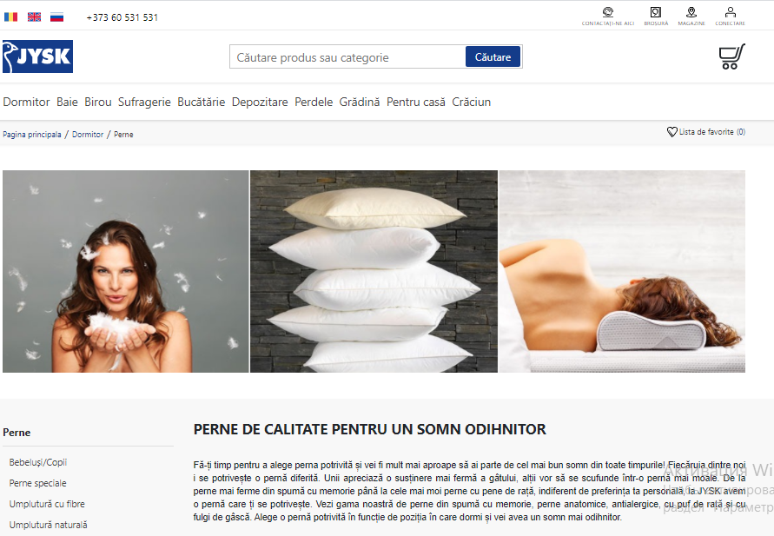

|  |  |  |  |  |  |  |  |  |  |
| --- | --- | --- | --- | --- | --- | --- | --- | --- | --- |
| **Heading** | | **Text de baza** | | **Menu** | | **Butoane** | | **Footer** | |
| *Font* | Roboto,"helvetica neue" | *Font* | Arial | *Font* | Roboto,"helvetica neue" | *Font* | Roboto,"helvetica neue" | *Font* | Roboto,"helvetica neue" |
| *Dimensiune* | 18px | *Dimensiune* | 18px | *Dimensiune* | 12px | *Dimensiune* | 14px | *Dimensiune* | 14px |
| *Aliniere* | Left | *Aliniere* | Left | *Aliniere* | Left | *Aliniere* | Center | *Aliniere* | Left |
| *Culoare* | Negru | *Culoare* | Justify | *Culoare* | Цвет черного моря(#143c8a) | *Culoare* | Negru | *Culoare(font)* | Negru |
| *Bakground* | Transparent |  |  |  |  | *Background* | Transparent | *Bakground* | Transparent |

Disponibil: <https://www.apteka.md/ru>

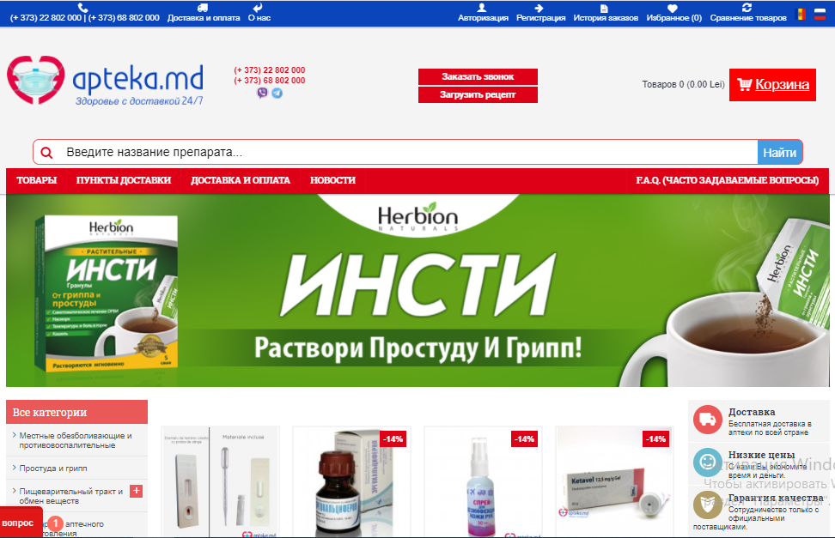

|  |  |  |  |  |  |  |  |  |  |
| --- | --- | --- | --- | --- | --- | --- | --- | --- | --- |
| **Heading** | | **Text de baza** | | **Menu** | | **Butoane** | | **Footer** | |
| *Font* | Helvetica,arial,sans-serif; | *Font* | Helvetica neue | *Font* | Roboto slab | *Font* | Roboto | *Font* | Helvetica neue |
| *Dimensiune* | 13px | *Dimensiune* | 14px | *Dimensiune* | 14px | *Dimensiune* | 14px | *Dimensiune* | 14px |
| *Aliniere* | Left/right | *Aliniere* | Center | *Aliniere* | Left | *Aliniere* | Center | *Aliniere* | Left |
| *Culoare* | Alb | *Culoare* | Negru | *Culoare* | Alb | *Culoare* | Alb | *Culoare(font)* | Alb |
| *Bakground* | Albastru |  |  |  |  | *Background* | Rosu | *Bakground* | Albastru |

Disponibil: <https://cadouri.md/ru/>

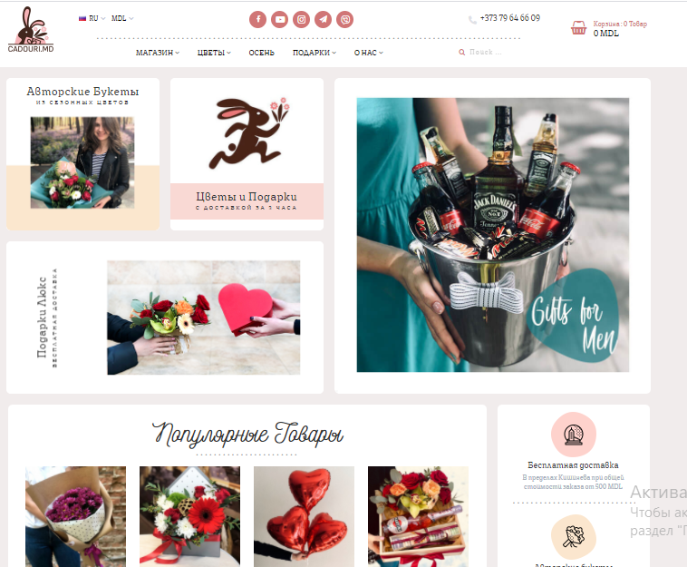

|  |  |  |  |  |  |  |  |  |  |
| --- | --- | --- | --- | --- | --- | --- | --- | --- | --- |
| **Heading** | | **Text de baza** | | **Menu** | | **Butoane** | | **Footer** | |
| *Font* | Basic-regular | *Font* | Basic-regular | *Font* | Basic-regular | *Font* | Basic-regular | *Font* | Basic-regular |
| *Dimensiune* | 14px | *Dimensiune* | 16,3px | *Dimensiune* | 13px | *Dimensiune* | 13px | *Dimensiune* | 15,4px |
| *Aliniere* | Left | *Aliniere* | Left | *Aliniere* | Left | *Aliniere* | Left | *Aliniere* | Left |
| *Culoare* | Negru | *Culoare* | Negru | *Culoare* | Negru | *Culoare* | Розовый антик(#d07676) | *Culoare(font)* | Кадетский синий крайола(#a9b1c0) |
| *Bakground* | Transparent |  |  |  |  | *Background* | Transparent | *Bakground* | Transparent |

Disponibil: <https://zendesign.md/en/projects/category/private-interior/>

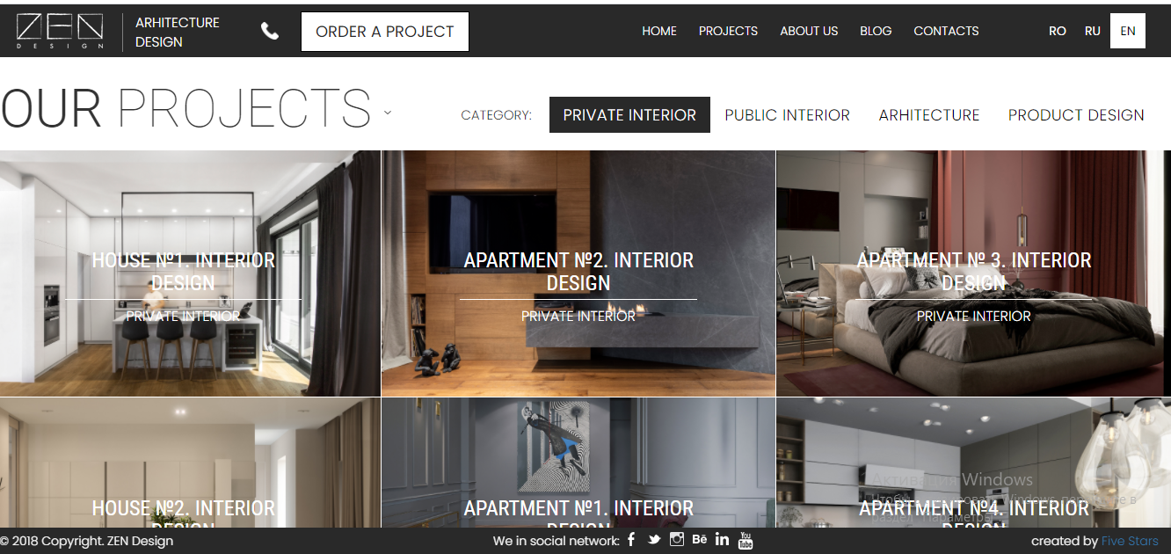

|  |  |  |  |  |  |  |  |  |  |
| --- | --- | --- | --- | --- | --- | --- | --- | --- | --- |
| **Heading** | | **Text de baza** | | **Menu** | | **butoane** | | **footer** | |
| *Font* | Poppins | *Font* | Roboto condensed | *Font* | Poppins | *Font* | Poppins | *Font* | Poppins |
| *Dimensiune* | 15,4px | *Dimensiune* | 24px | *Dimensiune* | 18px | *Dimensiune* | 18px | *Dimensiune* | 14px |
| *Aliniere* | Left | *Aliniere* | Center | *Aliniere* | Right | *Aliniere* | Right | *Aliniere* | Left |
| *Culoare* | Alb | *Culoare* | Alb | *Culoare* | Alb | *Culoare* | Negru | *Culoare(font)* | Alb |
| *Bakground* | Negru |  |  |  |  | *Background* | Alb | *Bakground* | Negru |

Disponibil: <https://kadikama.ru/disney/>

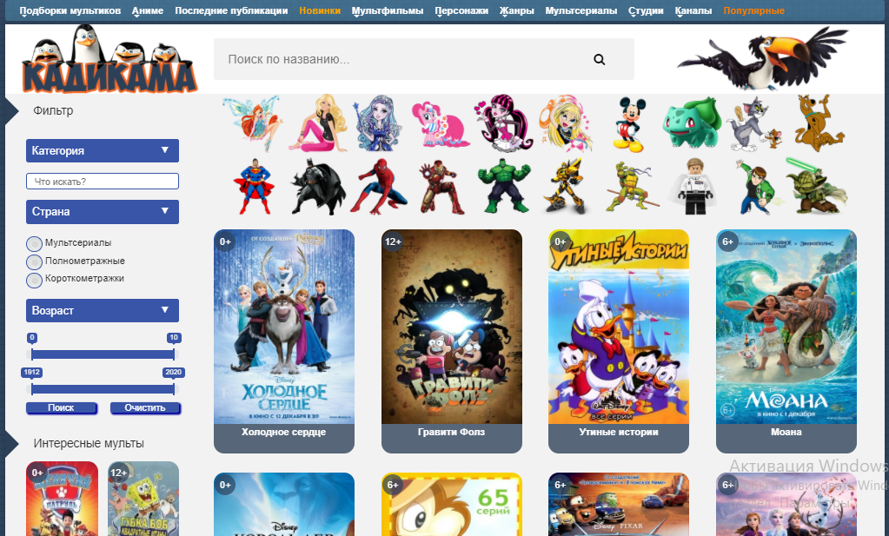

|  |  |  |  |  |  |  |  |  |  |
| --- | --- | --- | --- | --- | --- | --- | --- | --- | --- |
| **Heading** | | **Text de baza** | | **Menu** | | **Butoane** | | **Footer** | |
| *Font* | Arial | *Font* | Arial | *Font* | Arial | *Font* | Arial | *Font* | Arial |
| *Dimensiune* | 14px | *Dimensiune* | 14px | *Dimensiune* | 14px | *Dimensiune* | 14px | *Dimensiune* | 14px |
| *Aliniere* | Justify | *Aliniere* | Center | *Aliniere* | Justify | *Aliniere* | Center | *Aliniere* | Right |
| *Culoare* | Alb | *Culoare* | Alb | *Culoare* | Alb | *Culoare* | Alb | *Culoare(font)* | Alb |
| *Bakground* | Albastru |  |  |  |  | *Background* | Albastru | *Bakground* | Negru |

Disponibil: <https://www.povarenok.ru/recipes/show/167685/>

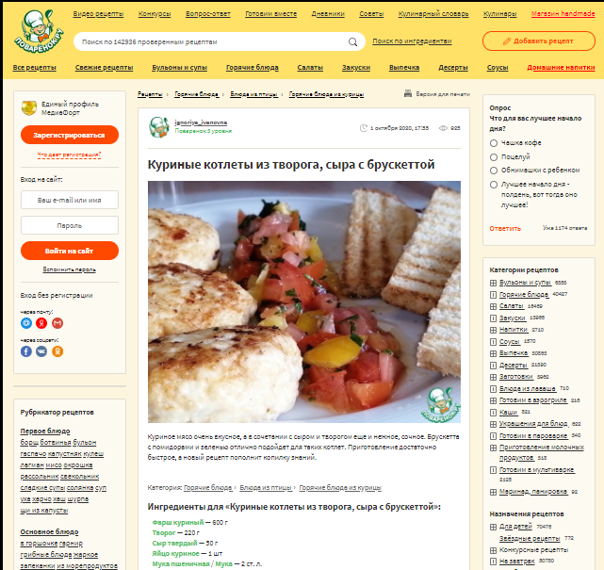

|  |  |  |  |  |  |  |  |  |  |
| --- | --- | --- | --- | --- | --- | --- | --- | --- | --- |
| **Heading** | | **Text de baza** | | **Menu** | | **Butoane** | | **Footer** | |
| *Font* | Source sans pro | *Font* | Source sans pro | *Font* | Source sans pro | *Font* | Source sans pro | *Font* | Source sans pro |
| *Dimensiune* | 14px | *Dimensiune* | 16px | *Dimensiune* | 16px | *Dimensiune* | 16px | *Dimensiune* | 16px |
| *Aliniere* | Justify | *Aliniere* | Left | *Aliniere* | Justify | *Aliniere* | Center | *Aliniere* | Left |
| *Culoare* | Negru | *Culoare* | Negru | *Culoare* | Negru | *Culoare* | Alb | *Culoare(font)* | Alb |
| *Bakground* | Одуванчиковый(#ffe168) |  |  |  |  | *Background* | Rosu | *Bakground* | Verde |

Disponibil: <https://www.sostav.ru/publication/top-20-novostnykh-media-runeta-6891.html>

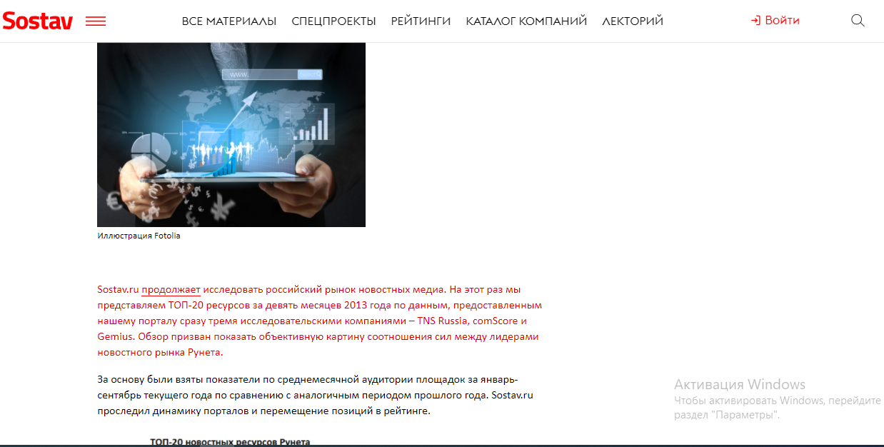

|  |  |  |  |  |  |  |  |  |  |
| --- | --- | --- | --- | --- | --- | --- | --- | --- | --- |
| **Heading** | | **Text de baza** | | **Menu** | | **Butoane** | | **Footer** | |
| *Font* | Euclidflex,sans-serif | *Font* | Pt sans',calibri,"san francisco",arial,sans-serif | *Font* | Euclidflex,sans-serif | *Font* | Euclidflex,sans-serif | *Font* | Arial,sans-serif |
| *Dimensiune* | 17px | *Dimensiune* | 20px | *Dimensiune* | 17px | *Dimensiune* | 14px | *Dimensiune* | 14px |
| *Aliniere* | Justify | *Aliniere* | Left | *Aliniere* | Justify | *Aliniere* | Center | *Aliniere* | Left |
| *Culoare* | Negru | *Culoare* | Negru | *Culoare* | Negru | *Culoare* | Alb | *Culoare(font)* | Negru |
| *Bakground* | Transparent |  |  |  |  | *Background* | Rosu | *Bakground* | Розово-лавандовый(#ffe1e9) |